

IT342-G4
System Integration and Architecture

System Design Document (SDD)

Project Title: MediGo
Prepared By: Ramirez, Ruther Gerard Lucabon

Version: 0.2
Date: 02/25/2026
Status: Review

REVISION HISTORY TABLE
Version | Date | Author | Changes Made | Status
0.1 | 02/18/2026 | Ramirez, Ruther | Initial draft based on project requirements | Draft
0.2 | 02/25/2026 | Ramirez, Ruther | Corrected domain models, updated API endpoints, DB, UI/UX, and Agile sprint plan for healthcare booking | Review
0.3 | [Date] | [Your Name] | Updated database design | Review
0.4 | [Date] | [Your Name] | Added UI/UX designs | Review
0.5 | [Date] | [Your Name] | Incorporated feedback | Revised
0.6 | [Date] | [Your Name] | Final review and corrections | Final
1 | [Date] | [Your Name] | Baseline version for development | Approved

TABLE OF CONTENTS
Contents
EXECUTIVE SUMMARY 4
1.0 INTRODUCTION 5
2.0 FUNCTIONAL REQUIREMENTS SPECIFICATION 5
3.0 NON-FUNCTIONAL REQUIREMENTS 9
4.0 SYSTEM ARCHITECTURE 11
5.0 API CONTRACT & COMMUNICATION 12
6.0 DATABASE DESIGN 17
7.0 UI/UX DESIGN 18
8.0 PLAN 21

EXECUTIVE SUMMARY
1.1 Project Overview
MediGo is a multi-platform healthcare appointment booking system designed to simplify how patients find doctors and clinics while enabling healthcare providers to manage bookings efficiently. The system integrates a Spring Boot REST API, React Web Application, and Android Mobile Application, ensuring seamless interaction across platforms.
Patients can search for clinics and doctors, filter by specialization and location, book appointments, and communicate with doctors through in-system messaging. Doctors can manage profiles, schedules, and appointment statuses.
1.2 Objectives
- Develop a fully functional appointment system MVP with authentication, search and filter, booking/cancellation, and online communication.
- Implement a three-tier architecture using Spring Boot (backend), React (web), and Android (mobile).
- Create RESTful APIs for communication between all system components.
- Design a responsive user interface that works consistently across web and mobile platforms.
- Deploy all system components to production-ready environments.
1.3 Scope
Included Features:
- User registration and authentication (email/password).
- Hospital/Clinic listing with search and filter functionality.
- Online communications between patients and doctors.
- Booking process functionality.
- Responsive web interface.
- In-system Notifications system (internal alerts).
- Appointment type specifications (check-up, follow-up, etc.).
Excluded Features:
- Email Notifications system.
- External Push Notifications (Mobile OS level).
- Payment Gateway processing (MVP focuses on booking only).

1.0 INTRODUCTION
1.1 Purpose
This document serves as the comprehensive design specification for the MediGo MVP system. It provides detailed requirements, architectural decisions, API contracts, database design, and implementation roadmap to guide development and ensure all components integrate seamlessly.

2.0 FUNCTIONAL REQUIREMENTS SPECIFICATION
2.1 Project Overview
Project Name: MediGo
Domain: Healthcare
Primary Users: Patients and Doctors
Problem Statement: Users (patients and doctors) need a simple and fast way to book and receive bookings on specific doctors or health clinics, without the complexity of booking personally.
2.2 Core User Journeys
Journey 1: Patient Appointment Booking
- Patient visits the web application or mobile app.
- Registers/Logs in with credentials.
- Searches for a clinic or doctor using filters (location, specialization).
- Selects a doctor to view profile and available schedules.
- Chooses an appointment type (check-up, follow-up).
- Confirms booking details.
- Receives in-system notification of successful booking.
Journey 2: Doctor Schedule Management
- Doctor logs in to their dashboard.
- Updates personal information and clinic details.
- Views list of incoming appointment requests.
- Communicates with patients via in-system messaging if necessary.
- Manages appointment status (Completed/Cancelled).
Journey 3: Administrator Management
- Admin logs in with admin credentials.
- Verifies and approves new clinic/doctor registrations.
- Manages user accounts.
- Views system-wide booking statistics.
2.3 Feature List (MoSCoW)
MUST HAVE
- User authentication (Patient/Doctor login).
- Doctor/Clinic Search and Filter.
- Appointment Booking System (Create, Cancel).
- Doctor Profile Management.
- In-system Chat/Messaging.
SHOULD HAVE
- Appointment History view.
- Doctor ratings or reviews.
- Profile picture upload.
COULD HAVE
- Map integration for clinic location.
- Prescription attachment.
WON'T HAVE
- Email integration.
- External Push notifications.
- Payment Gateway processing.
2.4 Detailed Feature Specifications
Feature: User Authentication
- Screens: Registration (Patient/Doctor selection), Login.
- Fields: Email, Password, Name, Role.
- API Endpoints: POST /auth/register, POST /auth/login.
Feature: Search & Filter
- Screens: Home Search, Results List.
- Functions: Search by name, filter by specialization or hospital.
- API Endpoints: GET /doctors, GET /doctors/search?query={x}.
Feature: Booking System
- Screens: Doctor Detail, Booking Form, My Appointments.
- Functions: Select time slot, choose appointment type (Check-up/Follow-up), Confirm.
- API Endpoints: POST /appointments, GET /appointments/{id}, PUT /appointments/{id}/cancel.
Feature: Online Communication
- Screens: Chat Window.
- Functions: Send text message between booked patient and doctor.
- API Endpoints: POST /messages, GET /messages/{appointmentId}.
2.5 Acceptance Criteria

AC-1: User Registration
Given a user provides valid registration details
When they submit the registration form
Then an account should be created
And the user should be redirected to login

AC-2: User Login
Given a registered user
When valid credentials are entered
Then a JWT token is issued
And the user is redirected to their dashboard

AC-3: Doctor Search
Given a patient is logged in
When they search by specialization or name
Then matching doctors should be displayed

AC-4: Appointment Booking
Given a patient selects a valid time slot
When booking is confirmed
Then the appointment is saved
And the doctor sees it in their dashboard

AC-5: Appointment Cancellation
Given an upcoming appointment
When the patient cancels
Then the status updates to “Cancelled”

AC-6: Messaging
Given an active appointment
When a message is sent
Then it appears in the chat thread in real time

AC-7: Doctor Profile Update
Given a logged-in doctor
When profile information is updated
Then changes are saved successfully

AC-8: Admin Approval
Given a new doctor registration
When admin approves
Then the doctor account becomes active

3.0 NON-FUNCTIONAL REQUIREMENTS
3.1 Performance Requirements
The MediGo system must provide reliable and responsive performance across web and mobile platforms to ensure a smooth booking experience.
- API response time shall not exceed 2 seconds for 95% of requests.
- Web application initial page load shall not exceed 3 seconds on standard broadband.
- Android mobile application cold start time shall not exceed 3 seconds.
- System shall support at least 100 concurrent active users.
- Database query execution time shall not exceed 500 milliseconds.
3.2 Security Requirements
Given that MediGo handles sensitive healthcare-related data, strong security controls are required.
- All client–server communication must use HTTPS (TLS 1.2 or higher).
- Authentication shall be implemented using JWT (JSON Web Tokens).
- Passwords must be hashed using bcrypt with a minimum of 12 salt rounds.
- Role-based access control (RBAC) shall be enforced (Patient, Doctor, Admin).
- Input validation shall be implemented to prevent SQL Injection.
- API rate limiting shall restrict requests to 100 requests per minute per IP.
3.3 Compatibility Requirements
The system must operate consistently across supported platforms and devices.
- Web Browsers: Chrome, Firefox, Safari, Edge (latest two versions).
- Android OS: Android 7.0 (API Level 24) and above.
- Screen Sizes:
  - Mobile: 360px and above
  - Tablet: 768px and above
  - Desktop: 1024px and above
- Operating Systems:
  - Windows 10 and above
  - macOS 10.15 and above
  - Linux Ubuntu 20.04 and above
3.4 Usability Requirements
The MediGo system must be easy to learn and efficient to use.
- First-time users should be able to complete an appointment booking within 5 minutes
- Web application shall comply with WCAG 2.1 Level AA accessibility standards
- Navigation structure must be consistent across all pages
- Error messages must be clear, user-friendly, and provide recovery guidance
- Touch targets on mobile must be at least 44x44 pixels
- Keyboard navigation support must be provided for the web application

4.0 SYSTEM ARCHITECTURE
4.1 Component Diagram
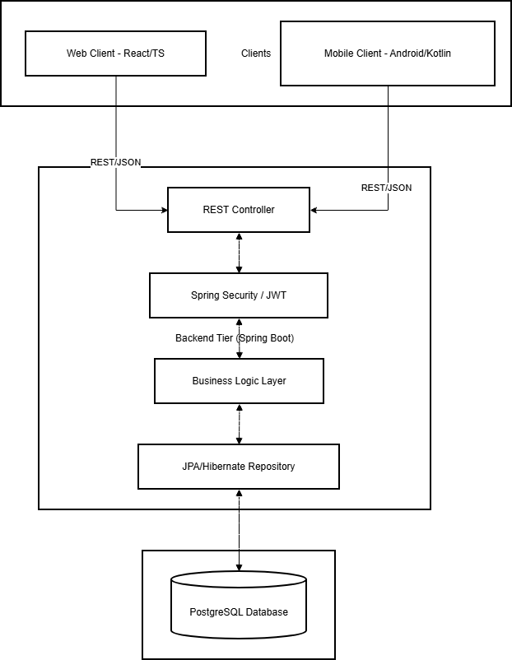
Technology Stack:
- Backend: Java 17, Spring Boot 3.x, Spring Security, Spring Data JPA
- Database: PostgreSQL 14+
- Web Frontend: React 18, TypeScript, Tailwind CSS, Axios
- Mobile: Kotlin, Jetpack Compose, Retrofit, Room
- Build Tools: Maven (Backend), npm/yarn (Web), Gradle (Android)

5.0 API CONTRACT & COMMUNICATION
5.1 API Standards
- Base URL: https://api.medigo.com/api/v1
- Data Format: JSON
- Authentication: Bearer Token (JWT)
- Response Structure:
{
"success": true,
"data": {},
"error": null,
"timestamp": "2026-02-25T10:30:00Z"
}

5.2 Endpoint Specifications
Authentication Endpoints
Method | Endpoint | Description
POST | /auth/register | Register new Patient or Doctor account
POST | /auth/login | Authenticate user and return JWT
POST | /auth/logout | Invalidate current session/token

Healthcare Provider Endpoints
Method | Endpoint | Description
GET | /doctors | List doctors with pagination and basic filters
GET | /doctors/search | Search by name, specialization, or clinic location
GET | /doctors/{id} | Detailed profile, qualifications, and available slots
GET | /clinics | List registered clinics/hospitals

Appointment Endpoints (Core Logic)
Method | Endpoint | Description
POST | /appointments | Create a new booking (Patient only)
GET | /appointments | Retrieve user-specific appointment history
GET | /appointments/{id} | View specific appointment details and status
PUT | /appointments/{id}/status | Update status (Confirm/Cancel/Complete)

Messaging Endpoints
Method | Endpoint | Description
GET | /messages/{appointmentId} | Fetch chat history for a specific booking
POST | /messages | Send a new message within an active booking context

5.3 Error Handling
HTTP Status Codes
- 200 OK: Successful request.
- 201 Created: Appointment or Account successfully created.
- 400 Bad Request: Invalid input (e.g., date in the past).
- 401 Unauthorized: Missing or expired JWT.
- 403 Forbidden: Patient trying to access Admin/Doctor routes.
- 409 Conflict: The selected time slot is already booked.
Error Code Examples
json
{
"success": false,
"data": null,
"error": {
"code": "APPT-001",
"message": "Schedule conflict",
"details": "The selected time slot (10:30 AM) is no longer available."
},
"timestamp": "2026-02-25T11:00:00Z"
}

Common Error Codes
Code | Message | Description
AUTH-001 | Invalid credentials | Wrong email or password
APPT-001 | Schedule conflict | Slot already taken by another patient
APPT-002 | Invalid Type | Appointment type not supported by this doctor
SYS-001 | Internal Error | Database or server connection failure

6.0 DATABASE DESIGN
6.1 Entity Relationship Diagram
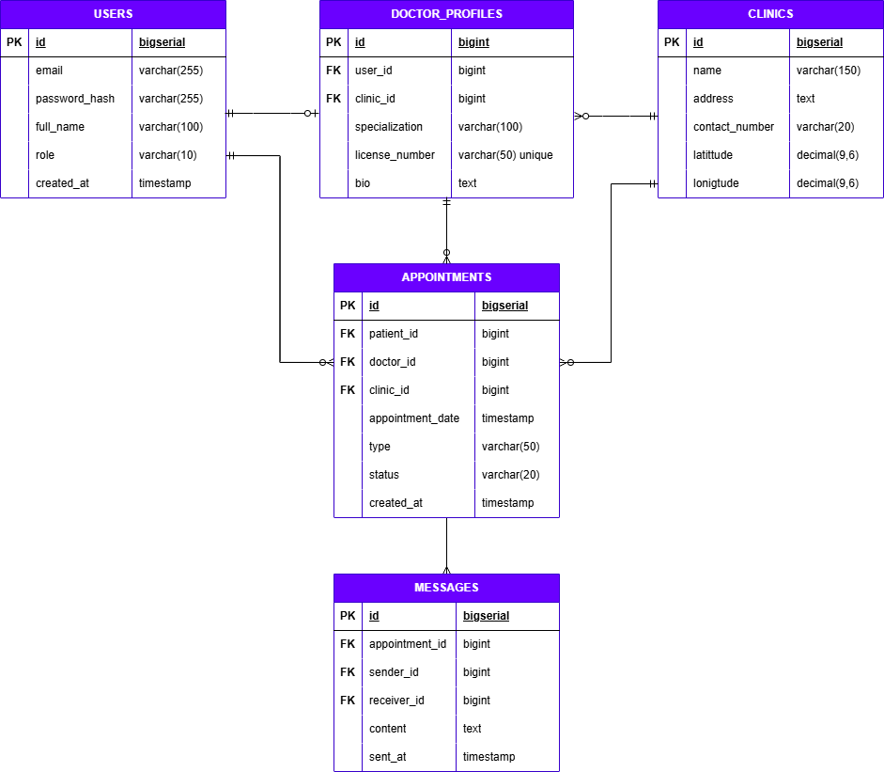

Detailed Relationships:
- One-to-One: User ↔ Doctor_Profile (A user with a DOCTOR role has one profile)
- Many-to-One: Doctor_Profile → Clinic (Doctors are associated with clinics)
- One-to-Many: User (Patient) → Appointments (A patient can have multiple appointments)
- One-to-Many: Doctor_Profile → Appointments (A doctor receives multiple appointments)
- One-to-Many: Appointment → Messages (An appointment can have a chat thread)
Key Tables:
- users: Stores core identity data and authentication credentials for all roles (Patient, Doctor, Admin).
- doctor_profiles: Contains professional details for users with the 'DOCTOR' role, including specialization and bio.
- clinics: Stores information about healthcare facilities, including their physical address and contact details.
- appointments: The central transaction table that links a patient, doctor, and clinic for a specific date and time.
- messages: Stores the chat history between patients and doctors, strictly scoped to a specific appointment.
- refresh_tokens: Manages JWT refresh tokens to maintain secure, long-lived user sessions without constant re-login.
Table Structure Summary:
- users: id, email, password_hash, full_name, role, created_at
- doctor_profiles: id, user_id, clinic_id, specialization, license_number, bio
- clinics: id, name, address, contact_number, latitude, longitude
- appointments: id, patient_id, doctor_id, clinic_id, appointment_date, type, status, created_at
- messages: id, appointment_id, sender_id, receiver_id, content, sent_at

7.0 UI/UX DESIGN
7.1 Web Application Wireframes
Homepage (Search & Discovery)
Header: [Logo] [Search Bar] [My Appointments] [User Menu]
Content: Filter bar (Specialty, Location), Doctor/Clinic Grid Cards
Each Card: Doctor Image, Name, Specialty, Clinic Name, "Book Now" button
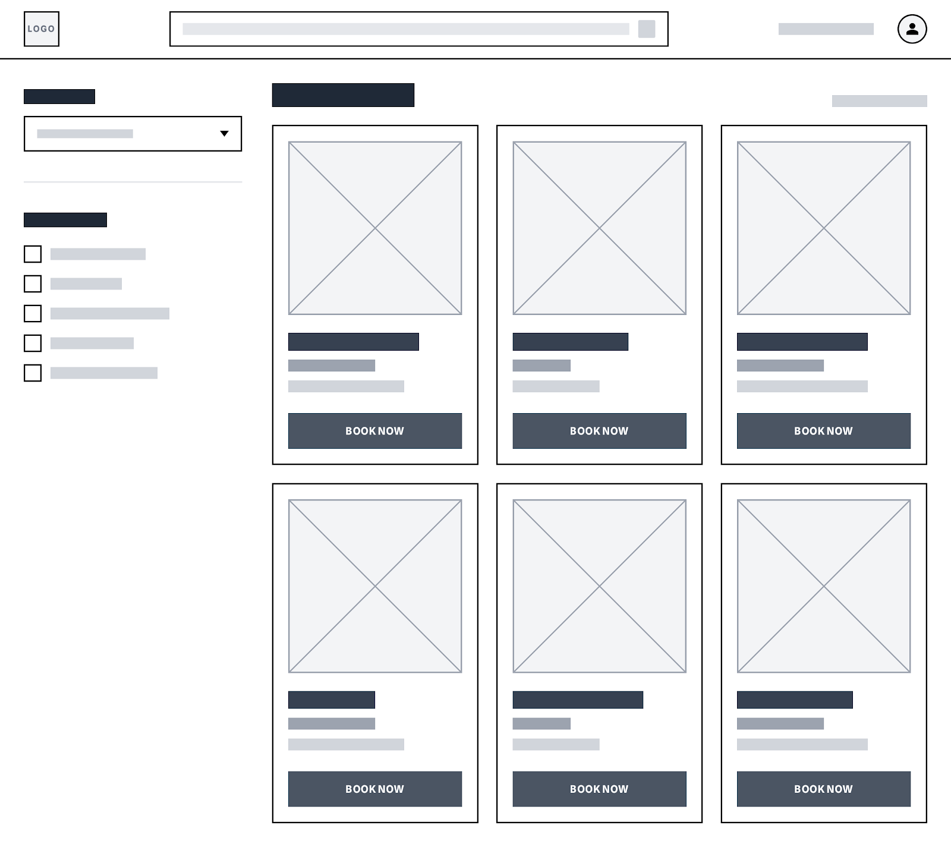

Doctor Detail Page
Doctor Profile Info (Bio, Qualifications)
Interactive Calendar for Schedule Selection
Appointment Type Dropdown
"Confirm Booking" button
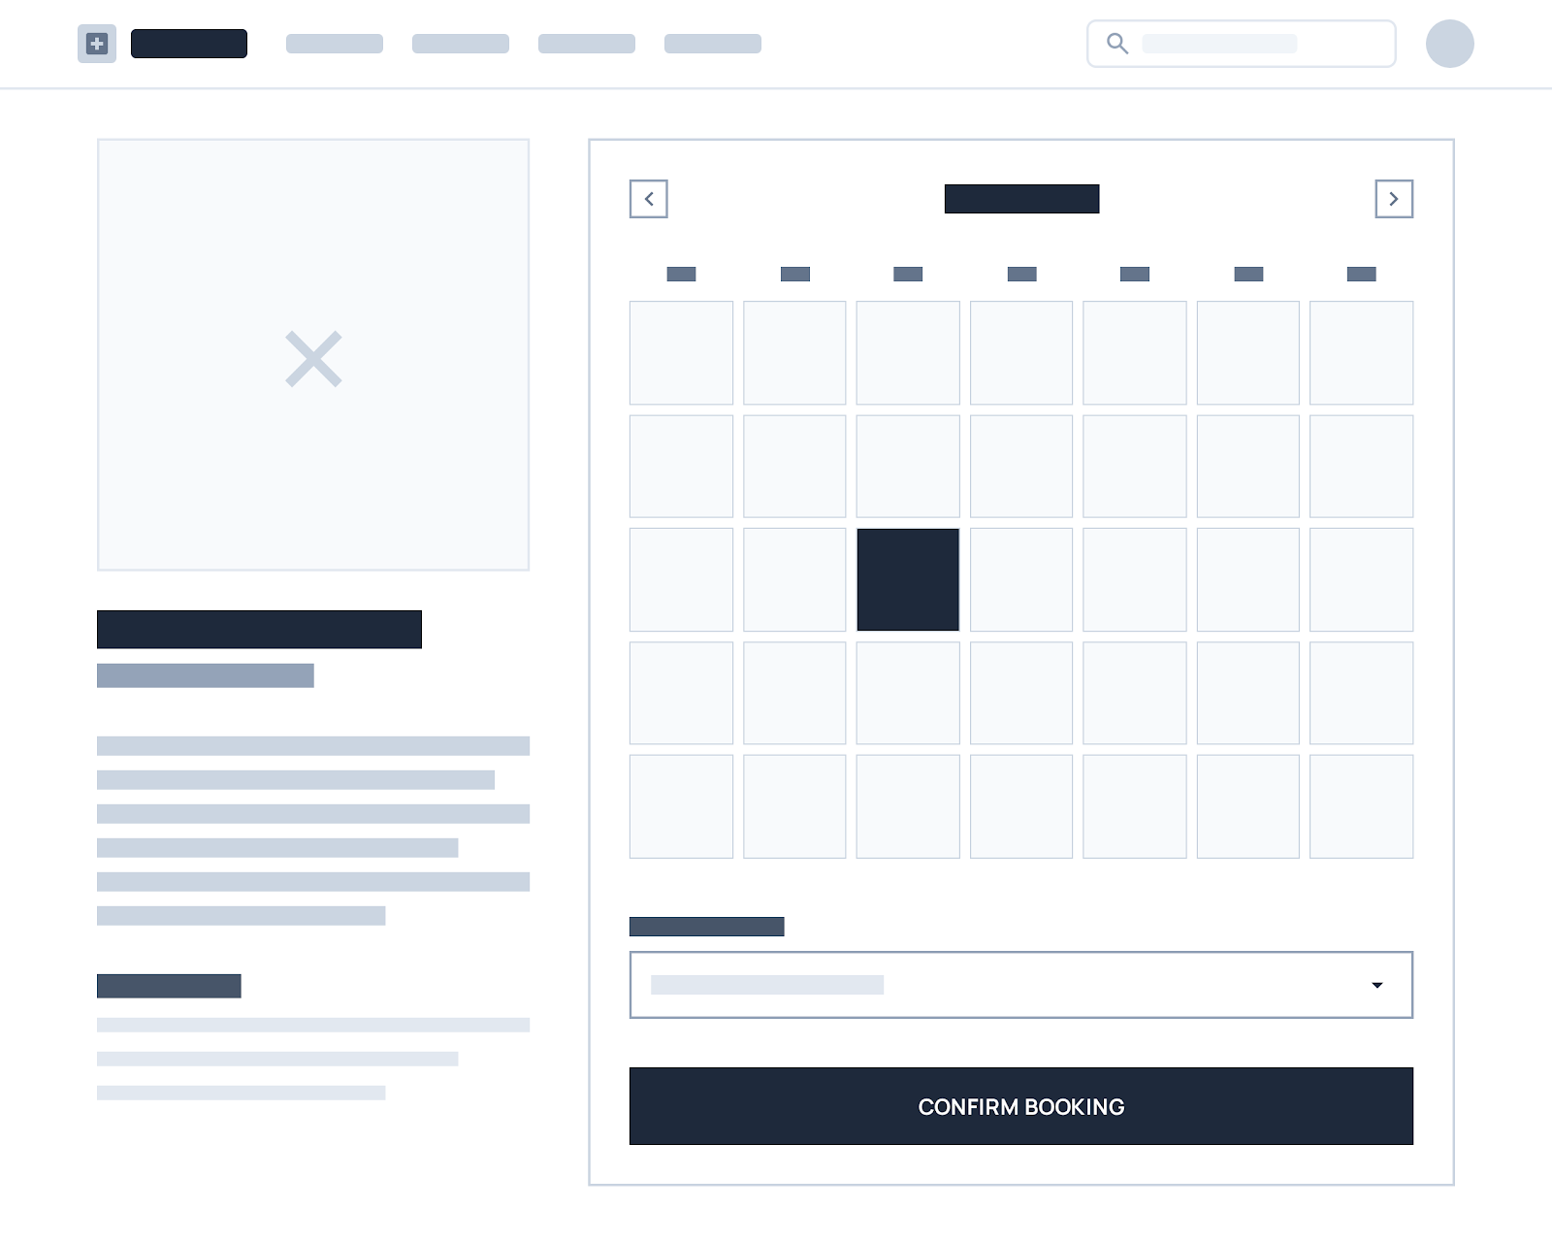

Patient Dashboard (My Appointments)
Tabs: Upcoming, Completed, Cancelled
List of Appointments with Status Badges
Action Buttons: Reschedule, Cancel, Message Doctor
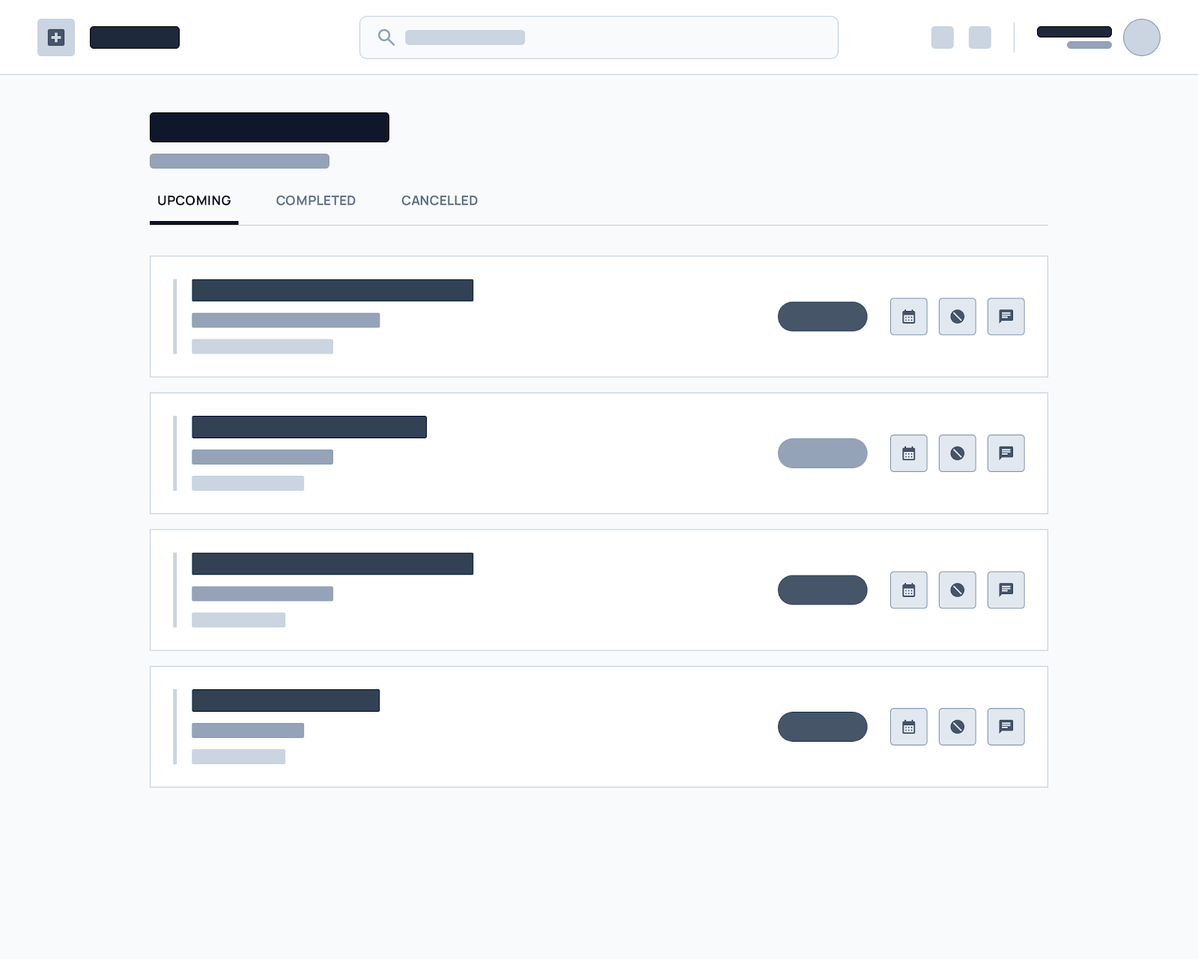

Chat Interface
Sidebar: Active Appointment Chats
Main View: Chat history bubbles, Message input field, Send button
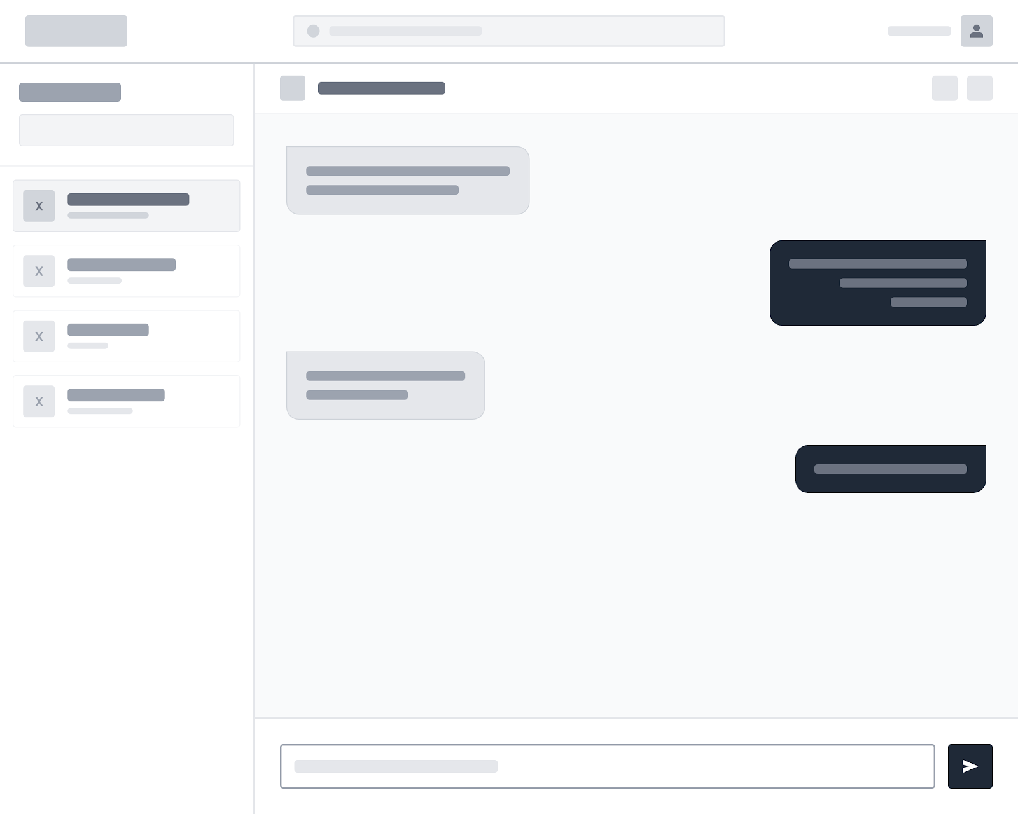

7.2 Mobile Application Wireframes
Bottom Navigation
[🏠 Home] [📅 Appointments] [💬 Messages] [👤 Profile]

Home Screen
Search Bar
Quick Categories (e.g., Dental, Cardio, General)
Horizontal scroll for Top Rated Doctors
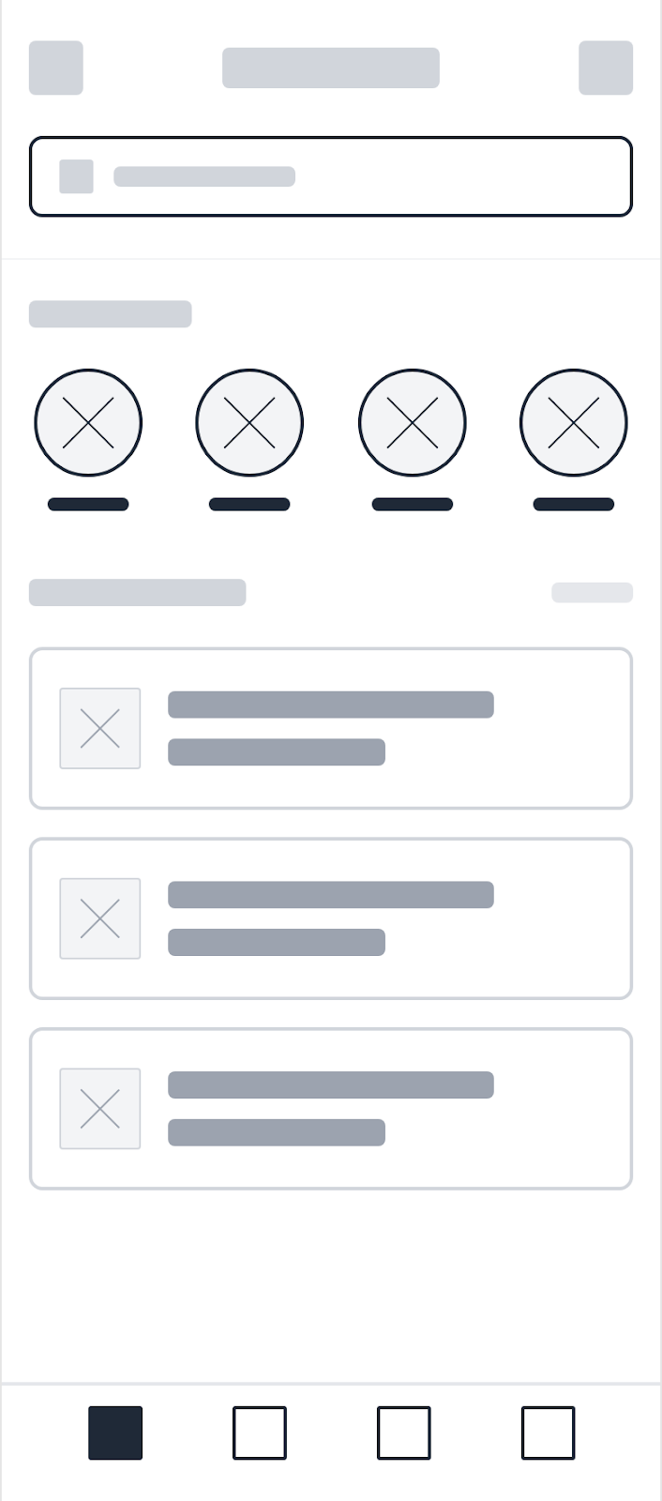
Doctor Detail & Booking Page
Header: Step indicator (Select Doctor → Pick Date/Time → Add Notes → Confirm) Content: Doctor Profile Info, Touch-optimized calendar grid (min 44x44px) Interaction: Bottom Sheet modal for time slot selection Action: "Confirm" button
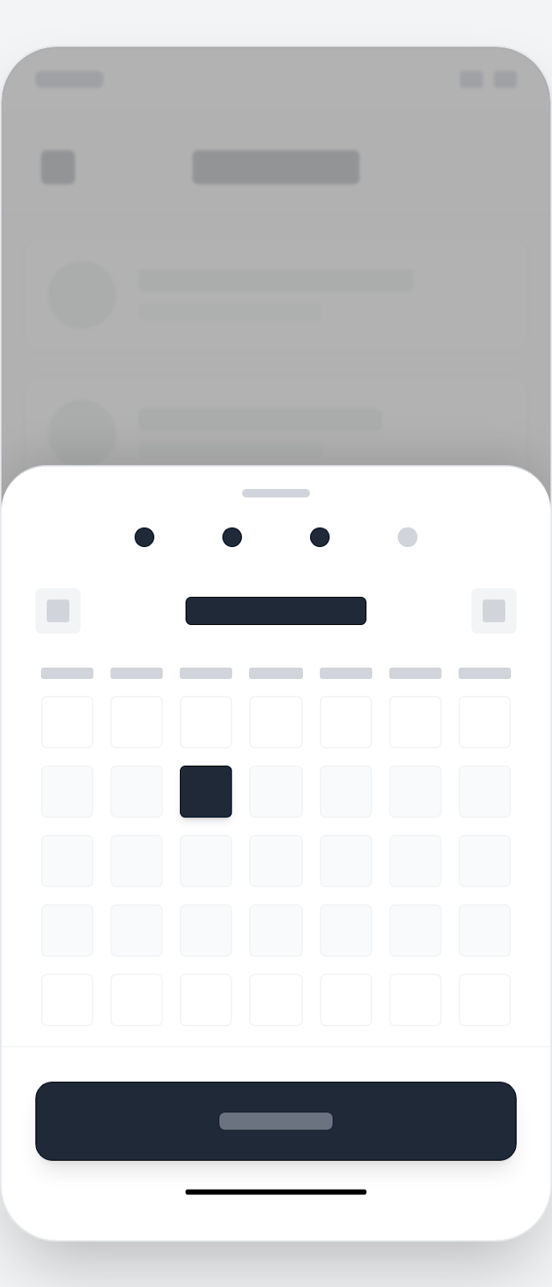
Patient Dashboard (My Appointments)
Tabs: Upcoming, Past (Swipe gestures to switch between tabs)
List of Appointments: Doctor details with Status Badges
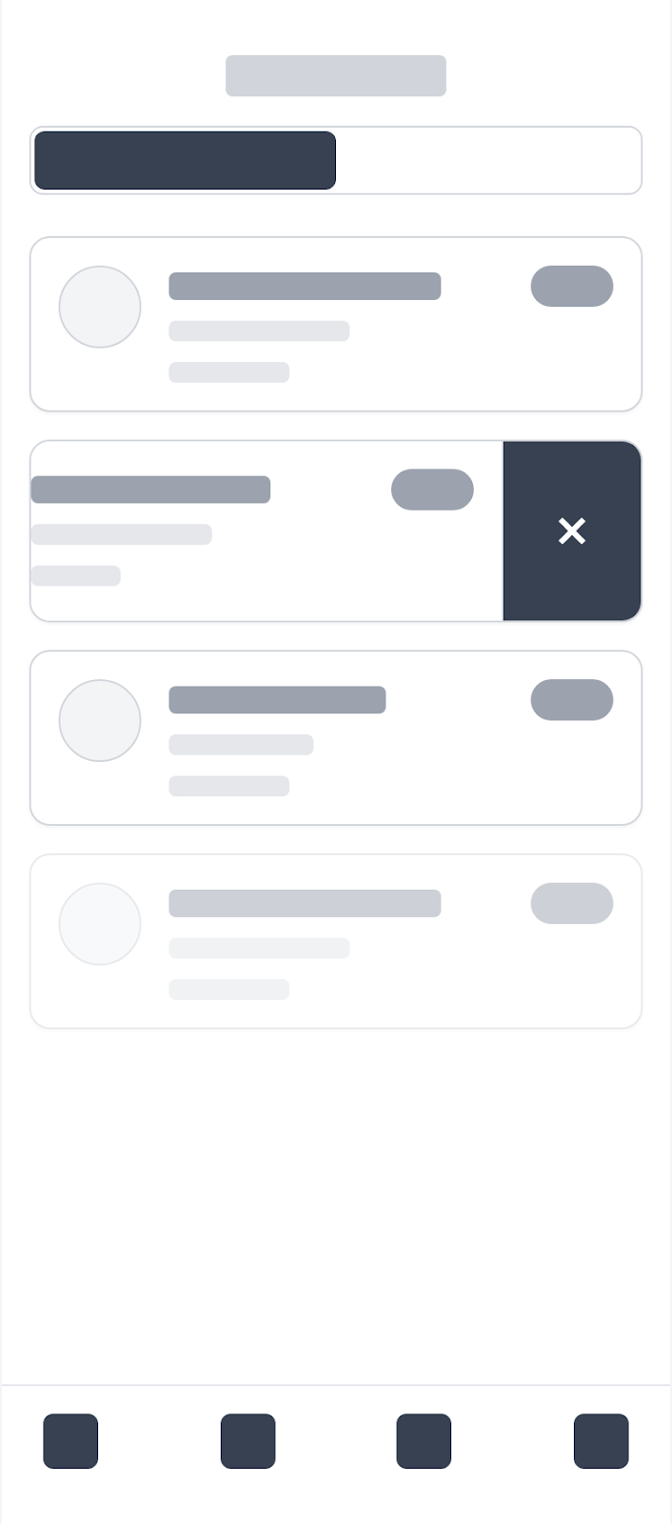
Chat Interface
Header: Active Doctor Name and Avatar (Back button to exit)
Main View: Chat history bubbles (Real-time chat layout optimized for virtual keyboards)
Footer: Message input field, Send button
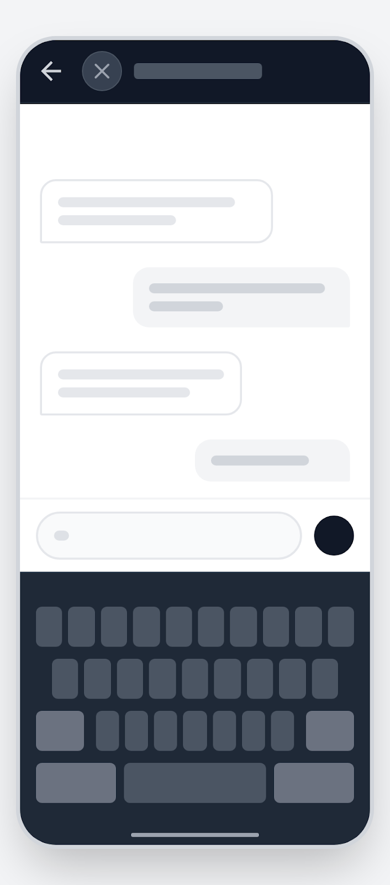

Booking Flow
Step indicator: Select Doctor → Pick Date/Time → Add Notes → Confirm
Bottom Sheet modal for time slot selection

Mobile-Specific Features:
Touch-optimized calendar grid (min 44x44px).
Swipe gestures to switch between Upcoming and Past appointments.
Real-time chat layout optimized for virtual keyboards.

Design System:
- Colors: Primary (#2563EB), Secondary (#7C3AED), Success (#10B981), Error (#EF4444).
- Typography: Inter font family, responsive sizing (H1: 32px, Body: 16px).
- Spacing: 8px grid system for all margins, padding, and component alignment.
- Components: Consistent buttons (8px radius), inputs, doctor cards, and confirmation modals.
- Responsive: Mobile-first approach, breakpoints at 640px (Mobile), 768px (Tablet), 1024px (Desktop).

8.0 PLAN
8.1 Project Timeline
Phase 1: Planning & Design (Week 1-2)
Week 1: Requirements & Architecture
- Day 1-2: Project setup and documentation.
- Day 3-4: Complete Functional (FRS) and Non-Functional (NFR) requirements.
- Day 5-7: System architecture and tech stack finalization.

Week 2: Detailed Design
- Day 1-2: API specification and contract mapping.
- Day 3-4: Database schema design (ERD).
- Day 5-6: UI/UX wireframes (Figma) for Patient and Doctor flows.
- Day 7: Final review of the Design Document.

Phase 2: Backend Development (Week 3-4)
Week 3: Foundation & Security
- Day 1: Spring Boot setup and project structure.
- Day 2: Database migration and JPA Entity creation.
- Day 3: JWT Authentication & Role-Based Access Control (RBAC).
- Day 4: User and Doctor Profile management endpoints.
- Day 5: Clinic/Hospital listing and search logic.

Week 4: Core Booking Logic
- Day 1: Appointment scheduling and slot availability logic.
- Day 2: Booking status management (Confirm/Cancel/Complete).
- Day 3: In-system Messaging/Chat API.
- Day 4: Search filters (Specialization, Location).
- Day 5: Unit testing and API documentation (Swagger/OpenAPI).

Phase 3: Web Application (Week 5-6)
Week 5: Frontend Foundation
- Day 1: React setup with TypeScript and Tailwind CSS.
- Day 2: Auth pages (Login/Register) & Protected Routes.
- Day 3: Doctor Discovery/Search results page.
- Day 4: Doctor Profile & Details view.
- Day 5: Booking interaction & slot selection UI.

Week 6: Complete Web Features
- Day 1: Patient Dashboard (My Appointments).
- Day 2: Doctor Dashboard (Schedule & Patient Management).
- Day 3: Real-time Chat interface.
- Day 4: Admin Panel for Doctor/Clinic approval.
- Day 5: Integration testing with Backend.

Phase 4: Mobile Application (Week 7-8)
Week 7: Android Foundation
- Day 1: Android Studio setup (Kotlin/Jetpack Compose).
- Day 2: Authentication and Profile screens.
- Day 3: Mobile-optimized Doctor search and filters.
- Day 4: Booking flow (Bottom sheets & Calendar components).
- Day 5: Retrofit service layer for API communication.

Week 8: Complete Mobile App
- Day 1: Appointment History and Management.
- Day 2: Mobile Chat UI (Real-time updates).
- Day 3: In-system alert/notification view.
- Day 4: UI polish, animations, and dark mode support.
- Day 5: Beta testing (APK/Internal testing).

Phase 5: Integration & Deployment (Week 9-10)
Week 9: Quality Assurance
- Day 1: End-to-end testing (Cross-platform sync).
- Day 2: Performance tuning (API response times).
- Day 3: Security auditing (JWT validation & SQLi checks).
- Day 4: User Acceptance Testing (UAT) simulation.
- Day 5: Bug fixes and final documentation updates.
Week 10: Deployment
- Day 1: Production Backend deployment (PostgreSQL + Spring Boot).
- Day 2: Web App deployment (Vercel/Cloud).
- Day 3: Mobile distribution (APK generation).
- Day 4: Final smoke tests in production.
- Day 5: Project hand-off/submission.

Milestones:
- M1 (Week 2): Design Freeze (No more major scope changes).
- M2 (Week 4): Backend API Ready for integration.
- M3 (Week 6): Web MVP Functional.
- M4 (Week 8): Mobile MVP Functional.
- M5 (Week 10): Full System Deployment.
Critical Path:
- Authentication & RBAC (Foundation for all roles).
- Booking Conflict Logic (Crucial for healthcare integrity).
- API Synchronization between Web and Mobile.

Risk Mitigation:
- Implement Database Locking: Use pessimistic or optimistic locking to prevent "double-booking" where two patients might claim the same time slot simultaneously.
- Enforce RBAC (Role-Based Access Control): Ensure that only authorized users can access sensitive data (e.g., Doctors cannot see other Doctors' patient lists; Patients cannot edit Clinic profiles).
- Start with simplest working version of each feature: Prioritize the basic "Search and Book" flow before adding complex features like chat or profile pictures.
- Test integration points early and often: Use tools like Swagger to ensure the Android and Web apps are perfectly synced with the Backend API from Week 3.
- Maintain strict MoSCoW adherence: Avoid "Scope Creep" by deferring non-essential features (like payment gateways) until the core MVP is stable.
- Keep backup of working versions: Utilize Git for version control and automated database backups to prevent data loss during development.
- Focus on core functionality before enhancements: Ensure the booking engine is 100% reliable before polishing UI animations or optional filters.

